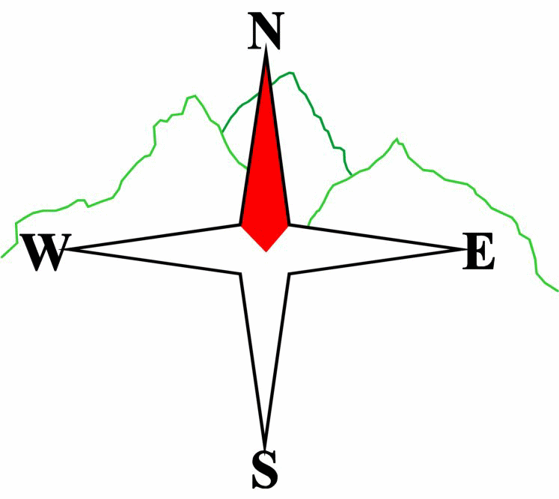 ***Blairgowrie & District Hillwalking Club***

**www.bdhc.org.uk**

**Ben Gulabin**

**24/11/2024**

**O.S. Map No**: 43

|  |  |  |  |  |
| --- | --- | --- | --- | --- |
| **Bus times:** | **Blairgowrie** (**Wellmeadow**): **08.00 am** | | **Alyth** (**Square**): **07.45 am** | |
|  |  | | | |
|  | | | | |
| A Walk – Ben Gulabin via Carn Bhinnein from Cairnwell | | | | |
| Start at Cairnwell ski centre NO138 782 go westwards up the track towards Loch Vrotachan. From the col traverse southwards to pt 808. Follow ridge SW to **Carn nan Sac (M top 920m)** then W to **Carn a’ Gheoidh** **(M 975m)**. Continue W then S to **Carn Bhinnein** **(M top 915m)** for spectacular views on a clear day. Traverse eastwards round corrie to pt 829 then follow track southwards over Carn Mor to **Ben Gulabin (C 806m)**. From summit go E to col then descend steeply SSW to the track in Glen Shee. Follow track eastwards to the Spittal. | | | | |
| Approx. distance: 18.2 km | | Total ascent: 750 m | | Min. **walking** time: 6 ¼ hrs |
|  | | | | |
| B Walk – Carn Ait | | | | |
| Start at the Spittal of Glenshee NO 110 698 cross the A93 and pick up the Cateran Trail to Tomb. Turn N up a path that tracks east of Bad an Loin. Keep right at a junction to its NE. Follow this N then NE as it climbs to S of Sron na Fionach. Climb E to summit of Carn Chom-Stri (718m). Follow ridge NNE to summit of **Carn Ait (C top 864m)**. Then walk E to col at 151 732 turning S to meet the start of a path at 148 719. Follow this down to where it meets the Cateran Trail. Turn right and follow NW back to start. | | | | |
| Approx. distance: 17.7 km | | Total ascent: 734 m | | Min. **walking** time: 6 hrs |
|  | | | | |
| C Walk– Cateran Trail from Spittal to Lair | | | | |
| Start at Spittal of Glenshee NO 110 698. Follow the Cateran tail southwards until it meets the A93. Walk 200m N to the excellent café and gift shop at Lair (**care on dangerous road)**. The walk may be extended by walking to Loch Beanie and back from the Glenshee Lodge (head east along path at 136 683 [add 5 km, 2 hrs]) | | | | |
| Approx. distance: 11.6 km | | Total ascent: minimal | | Min. **walking** time: 4.0 hrs |

The next club walk is on the **15th December- Xmas Walk** to Glen Isla starting at 07.45 am (Blairgowrie) and 08.00 am (Alyth). There will also be an informal ‘Twixt’ meet between Christmas and New Year. Details TBA.

**Please note that the Minimum walking times are based on reasonably fast walkers and assuming good conditions. The times do not include stops or breaks.**

## **In poor weather conditions or if members are not comfortable walking at 4km/hour then alternative or shorter routes should be considered.**

|  |  |
| --- | --- |
| IMPORTANT: YOUR SAFETY IN THE HILLS | |
| **The Committee reminds members and guests of the following important points:** | |
| * You are responsible for your own safety * Club officials are not trained mountain leaders * Are you fit enough to complete your chosen walk in the available time? * Know where you are going on the walk and follow the route on your map. * Know how many are in your party and stay together | * Ensure you have enough food plus emergency rations * Carry a map & compass, survival bag, torch, whistle and small first aid kit. Know how to use them. * In winter conditions you must carry an ice axe on high level walks (club rule). You are also recommended to carry crampons. * **Learn** how to use your equipment. |
|
|
|
|
|  |
| **Club officials will be happy to give advice on any of these points if requested.** | |